THE UNIVERSITY OF AZAD JAMMU & KASHMIR, MUZAFFARABAD


COURSE TITLE | OS
COURSE CODE | CS-2105
LAB TITLE | PROCESS CONTROL BLOCK
STUDENT NAME | HASEEB SHEIKH
STUDENT ROLL NUMBER | 2024-SE-31
INSTRUCTOR NAME | ENGR. SIDRA RAFIQUE
SUBMISSION DATE | OCT 31, 2025

DEPARTMENT OF SOFTWARE ENGINEERING
OS
Lab 4
Objective
To observe and relate the execution of a simple C++ program to the standard Process State Model used in Operating Systems (OS).
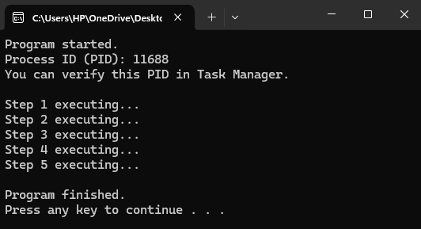
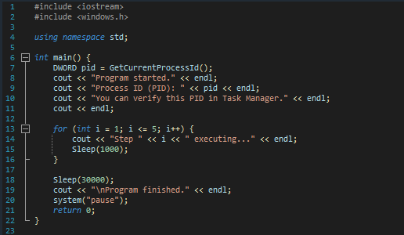
Code

Process in the task manager
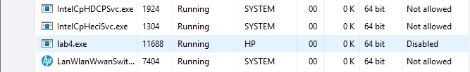

Process State Diagram.
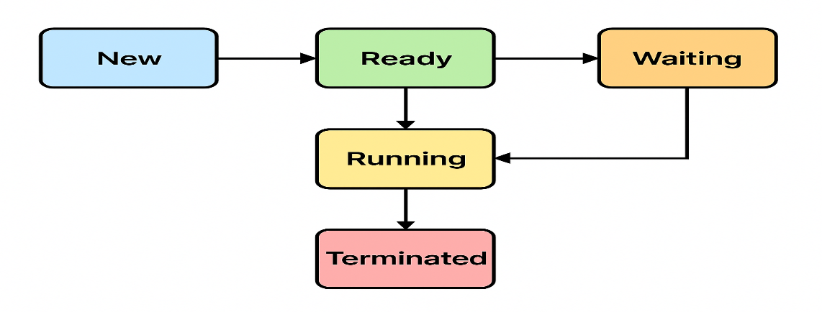

Explanation

Start State | End State | The Code Transition
New | Ready | Process Created / Executable Loaded
Ready | Running | OS Scheduler Dispatch (CPU Assigned)
Running | Waiting | Call to Sleep(30000) (Waiting for Timer Event)
Waiting | Running | Timer Expires (I/O Complete)
Running | Ready | Time Slice Expired (Preemption)
Running | Terminated | return 0; (Process Finishes)

Program Flowchart

